Project Proposal for Database

Distractors

by

1. MOHAMAD SYAFIEQ BIN MOHAMED (AI160010)

2. TOONG YEE KHEI (AI160181)

3. NG XIAO ZHEN (AI160197)

4. SITI UMATUSSHOLIKHAH BINTI DARSONO (AI160015)

5. KHALPHANADEVE A/P P.RAMACHANDRAN (AI160217)

A thesis submitted in partial fulfilment of the requirement for the award

of the Degree of Master of Computer Science (Multimedia)

Faculty of Computer Science and Information Technology

University Tun Hussein Onn

March 2018

**TABLE OF CONTENTS**

|  |  |  |
| --- | --- | --- |
| **1.0 PLANNING** | | |
|  | 1.1 Introduction of the Project | 1 |
|  | 1.2 Problem Defining | 2 |
|  | 1.3 Objective of the Project | 2 |
|  | 1.4 Scope of the Project | 3 |
|  | 1.5 Significance of project | 3 |
|  | 1.6 Chosen software process model | 4 |
|  | 1.7 Project Planning  1.7.1 Planning  1.7.2 Gantt Chart | 6  6  7 |
|  | 1.8 Interview question design | 8 |
| **2.0 ANALYSIS** | | |
|  | 2.1 Basic Concept, definition and Theory | 10 |
|  | 2.3 Data Gathering  2.3.1 Interview  2.3.2 Observation | 12  13  15 |
|  | 2.2 Existing System Investigation  (You may add here the as-is model system business process (flowchart/ any as-is Model) | 16 |
| **3.0 DESIGN** | | |
|  | 3.1 Introduction | 17 |

|  |  |  |
| --- | --- | --- |
|  | 3.2 Dataflow Diagram - Context Diagram & DFD | 18 |
|  | 3.3 Software and Hardware Requirements | 19 |
|  | 3.4 System Flow Chart (for the proposed system) | 21 |
|  | Conclusion | 22 |
| **REFERENCE** | | 23 |

**1.0 PLANNING**

**1.1 Introduction of the project**

In this project, students need to identify manual system in an organization or company and assists the company by creating a prototype system which can improve the company’s current systems to serve their business needs. The company that was involved in our project study is Desa Mart in Parit Raja which is one of the branch stores from DESA MART SDN.BHD. The main product sold in this store is animal feeds for live stocks and they sell products in bulks and also in retails. From the research that was carried out beforehand, it is found that the store does not have any information recorded digitally. They manually record sales and the staff will check for the availability of stock every day. It may be less effective when they want to find the record of the sales and check inventory. So, the aim of the project is to create a computer based inventory system which will help to safe-keep its records. The owner will be able to find past year records easily by using the system’s search engine. This also might help boost the effectiveness and in turn help the store keep their information more organized. In other words, this inventory system will keep all the information and records of the store more secure as it has improved backup and recovery services.

**1.2 Problem definition**

After doing the research, it is found that the store does not have any inventory management system specially to keep their information and records. The owner manually writes down all the sales records in a book. This may cause less effectiveness and less secure to the store information. The lack of digital records will make it hard for the owner to search for a particular record. Owner and staffs will have a hard time finding any information and sales records on the products they sold. Besides, due to the manual records, it might increase security risks as manual records have a higher chance of getting stolen. It will also cause high costs for the owner to buy books to record the sales reports. The management will be affected and this will lead to a decrease in performance for the store.

**1.3 Objective of the project**

1. Create a system which can keep the order records, sales records and inventory information organized.
2. Built a system which can search appropriate information about the sales and inventory.
3. Help in increasing data security.
4. Allow the owner to check on the available stock before selling.
5. Improve the effectiveness in searching the order records, sales records and inventory of the product.
6. Minimize data inconsistency in the order records, sales records and inventory.

**1.4 Scope of the project**

In this project, the system is computer-based because it is more reliable in storing large data. Computer-based system will allow the owner to easily create, read, update and delete the data. The system is offline to increase data security. The system will have the database to keep the order, sales and inventory records. For order record, it will have a clear list of date, invoice no, product ID, quantity of ordered stock, supplier, product price and total price in ordering stock. The designed system will show the sales records of the store. For sales record, it will have a clear list of date, receipt no, product ID, quantity of product bought by customer, product price and total price to pay of sales. For the inventory, it will have a clear list of product name, product ID, category, number of stock and suppliers. The owner can search any characteristics of the product and the system will list it out. The system will also list out the product ID of the store’s inventory alphabetically. Besides, the system will sort the order record by invoice no and sales report by receipt number which will allow the owner to search for a particular sales record or order record easily.

**1.5 Significance of project**

Since the recording of sales records of the store that is involved in this project is manual, the end discussion is to build a computer-based inventory system which can help boost the store’s management by increasing the effectiveness of the store. We will learn how to create a database and discuss the techniques used to implement the system of the program. The aim of this project is to study the importance of analyzing the current manual system and implement a database system which can improve the effectiveness in management. The analysis of this information leads to the development of a concept for a new inventory database system. The system is designed and built based on the issues, for example, the observed store does not have an organized database system which cause less performance in management. Since it is generally known that the database can be search and retrieved very quickly without having to manually check the list to see because it shares collection of logically related data and a description of this data, designed to meet the information needs of an organization, so a computer-based inventory system is developed to solve the issues.

**1.6 Chosen software process model**

Figure 1.6.1 Throwaway Prototyping Model

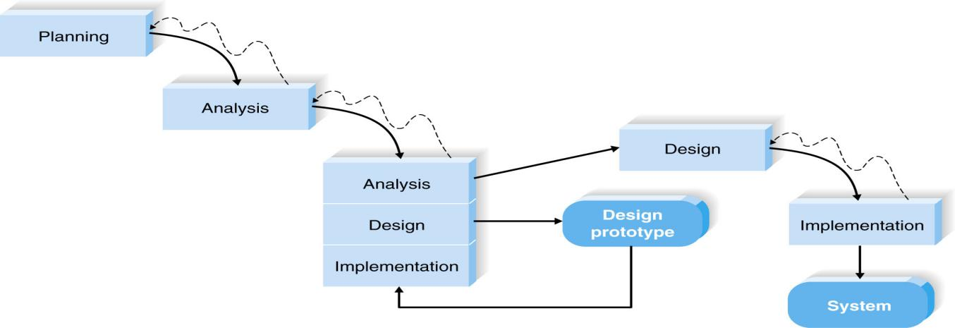

The chosen process model is Throwaway Prototyping. It includes the development of prototypes but uses the prototypes primarily to explore design alternatives rather that as the actual new system. Design prototypes are not intended to be a working system. It contains only enough details to enable users to understand the issues under consideration. It is suitable for project with unclear user requirement and unfamiliar technology.

Throwaway Prototyping Model is especially useful when the project needs are in question and are vaguely laid out. It functions by providing proof that something can indeed be done in terms of systems and strategies.

Throwaway Prototyping Model is used for certain projects and will eventually be discarded after the project has been completed. It is also known as Close-Ended Prototyping.

Throwaway Prototyping Model is implemented through the creation of prototypes and thereafter gathering feedback from end users to check if they find it good or not. This is valuable to get a better understanding of the actual needs of users for the product or system development.

There are many reasons why project teams use Throwaway Prototyping model. For one thing, it is very cost-effective. Since Throwaway Prototyping model uses a series of prototypes to detect and forecast possible problems, it can prevent these from taking place as soon as the product or service is introduced to the user.

Problems are usually a very costly occurrence, and if you can keep them from happening, expenses can be reduced. Next, project completion is quick. Since it allows early detection of issues, the transition from one step to the next will be smoother and faster.

Lastly, when you use Throwaway Prototyping model, you can be assured that the end result is something that will certainly work because it has been thoroughly tested through the use of prototypes. The end product is expected to be able to meet the wants and needs of the target user.

**1.7 Project Planning**

**1.7.1 Planning**

Project planning is part of project management, which relates to the use of schedules such as Gantt charts to plan and subsequently report progress within the project environment.

Project planning is at the heart of the project life cycle and tells everyone involved where the project is going and how it going to get there. The planning phase is when the project plans are documented, the project deliverables and requirements are defined, and the project schedule is created. It involves creating a set of plans to help guide the project team through the implementation and closure phases of the project. The plans created during this phase will help you manage time, cost, quality, changes, risk, and related issues. They will also help the project control staff and external suppliers to ensure that the project delivered on time, within budget, and within schedule.

The project planning phase is often the most challenging phase for a project manager, as it is needed to make an educated guess about the staff, resources, and equipment needed to complete your project. It may also need to plan the communications and procurement activities, as well as contact any third-party suppliers.

In this project, a database system is designed to keep the order, sales and inventory records of Desa Mart Sdn Bhd systematically after conducting initial research. We have decided to conduct an interview with the owner of Desa Mart to understand fully the issues that they face. We have provided the owner with a few selections of dates for the interview and prepared the interview question. All the team members are confirmed to be available on the few dates. It is decided that one day will be enough to conduct the interview.

After the interview, the team will analyze the interview and create a post interview follow-up. By using the report, each team members will set on analyzing and creating the design. Each team members will be given a specific task and execute their tasks accordingly.

**Interview**Final Project for Database

This interview is used for subject Database on reviewing the problem of the inventory system in Desa Mart Sdn Bhd in Parit Raja. All information given will be sworn on secrecy and will only be used in our assignment for the Database project.

1. What is the current inventory system used by Desa Mart Sdn Bhd？
2. Does the current inventory system work effectively in management?
3. What are the problems that Desa Mart Sdn Bhd is facing currently with the as-is system that you are using?
4. What is your opinion on the computer-based inventory system? Is it effective?
5. Does the company’s manager consider manage the inventory digitally?
6. Refer to question 5, if yes, what kind of inventory system the company needs? If no, why?
7. What is your opinion about the risk of managing computer-based inventory system?

**2.0 ANALYSIS**

**2.1 Basic Concept, definition and Theory**

[Small](https://blog.resellerclub.com/why-is-promotion-important-for-a-business/) and [medium](https://blog.resellerclub.com/why-is-promotion-important-for-a-business/)-sized businesses really need to understand the importance of reliable database to keep all the information. Choosing a reliable database is an active process which needs to be very closely scrutinized for obtaining the best results. The database will help the company in many different ways such as increase effectiveness in management, keep all the records organized and obtain the required information easily. This in turn helps owner sort all the sales records and reports neatly. Database also enables the user to define, create, maintain, and control access to the database.

Basically, the database should be able to define the structure of database information, populate the database with appropriate information, manipulate the database and protect the database contents against accidental or deliberate corruption of contents[1]. The database designed should be able to define the structure of database information by defining descriptive attributes, data types and constraints all the while storing them as metadata. It also should be able to manipulate the database through CRUD functions which are Create, Read, Update and Delete. Besides, the database should involve secure access by the user and automatic recovery in the case of user or hardware faults.

After conducting the research, it is found out that the company Desa Mart Sdn Bhd, in Parit Raja that we chose to interview has a lack of a secure and effective inventory management. Furthermore, the company does all the sales recording manually in a book which can be easily misplaced or destroyed. So, it was decided to introduce a computer-based inventory system to the company that will allow the company to have a more effective and secure management of the store. These days, database can be one of the most effective storing data tools on the Internet as it has become a part of daily life for most, like to a school keeping the student records or police keeping criminal records. Through databases system, it is possible to store large number of records efficiently and they will take up less space[2]. Furthermore, the database system will allow the user to find, search, create, read, update and delete new and old information fast and easily. Records can also be sorted easily through newest to the oldest. And lastly, database system can be guaranteed more secure than traditional record keeping book.

This is the reason that it was decides to introduce the computer-based inventory system to the company as it is more convenient for the user to keep all the records safe and secure.

**2.2 Data Gathering**

Data gathering is the systematic approach to gathering and measuring information from a variety of sources to get a complete and accurate picture of an area of interest. [Data](http://searchdatamanagement.techtarget.com/definition/data) collection enables a person or organization to answer relevant questions, evaluate outcomes and [make predictions](http://searchsalesforce.techtarget.com/definition/predictive-analytics) about future probabilities and trends. Accurate data collection is essential to maintaining the integrity of research, making informed business decisions and ensuring [quality assurance](http://searchsoftwarequality.techtarget.com/definition/quality-assurance).

Data gathering is concerned with the accurate acquisition of data although methods may differ depending on the field, the emphasis on ensuring accuracy remains the same. The primary goal of any data gathering endeavor is to capture quality data or evidence that easily translates to rich data analysis that may lead to credible and conclusive answers to questions that have been posed.

Accurate data gathering is essential to ensure the integrity of the research, regardless of the field of study or data preference. The selection of appropriate data collection tools and instruments, which may exist, modified or totally new, and with clearly defined instructions for their proper use, reduces the chances of errors occurring during collection.

Distorted findings are often the result of improper data collection such as misleading questions on questionnaires, unknowingly omitting the collection of some supporting data, and other unintentional errors. This would lead to a skewed conclusion that may be useless.

The type of instrument used is depending on the data gathering method selected. So, in stage of data gathering is the most important step to complete a system as the system requirement and design are according to the data collected. Besides, the method to carry out data gathering also important as different method will has different data gathering that may affect the result of data collection..

**2.2.1 Interview**

In interviews, information is obtained through inquiry and recorded by enumerators. Structured interviews are performed by using survey forms, whereas open interviews are notes taken while talking with respondents. The notes are subsequently structured for further analysis. Open-ended interviews, which need to be interpreted and analyzed even during the interview, have to be carried out by well-trained observers and/or enumerators.

Although structured interviews can be used to obtain almost any information, as with questionnaires, information is based on personal opinion. Data on variables such as catch or effort are potentially subject to large errors, due to poor estimates or intentional errors of sensitive information.

Interviews can be conducted in person or over the telephone. Interviews can be done formally, semi-structured, or informally. Questions should be focused, clear, and encourage open-ended responses. Interviews are mainly qualitative in nature.

Since it was needed to directly get the accurate information about the as-is sales recording system and the needs for their ideal computer-based inventory system from the owner of the Desa Mart Sdn Bhd Parit Raja, it was decided to use the structure interviews for our data gathering. As structure interview always operates within formal written instrument referred as interview schedule. It was also required to design the question to be asked prior to interview including the order of the questions. The question was asked orally in face to face.

First of all, the owner of the company was interviewed about their as-is sales recording system and does the system work effectively in management. After interview, it was known that Desa Mart Sdn Bhd is still using normal physical books which consist of recording the sales by handwriting. It is a very traditional way to record their sales and it is not much secure and effective. The problem they face now towards their current managing is that it is practically handwritten by the owner.

Next, the owner was asked about their opinion toward the computer-based inventory system and what is the needs in creating their computer-based inventory system if their company is interested in to implement the system. Through the interview, we know that the owner of Desa Mart Sdn Bhd realize that it is harder to search for a particular information in a handwritten sales record books. It takes a hard time to search for the sales record one by one in the books. In these modern days, people will more prefer to fast and effective solution, since computer-based inventory system contain database that can save a large amount of data, it helps the user to improved backup and recovery services. Besides, the system can help user to search the full information about the product and sales by using the searching function in the system. The owner considered for a computer-based inventory system to improve their effectiveness in inventory.

Although the company had considered about creating a computer-based inventory system, the problem is they are still using the current sales recording system that need to write manually. After interviewing them, the reason the company does not want to implement the computer-based inventory system is that they think there is a high risk for using modern technology. Most of the staff they hire are in the ages that are not experienced well in using computer. For them to learn it, they need more time to learn how to use the computer-based inventory system well. Even for the ones that know well in running a computer system also need time to learn how to use it as different company have different computer-based inventory system. Besides, questions about the suppliers were asked during the interview, but since the information about the suppliers in Desa Mart Sdn Bhd is confidential, the details about how the suppliers system works in the shop are unknown.

After gathering all the data from interview, it is concluded that the current sales recording and inventory system in Desa Mart Sdn Bhd does not work effectively in management because handwriting sales record book is not secure. People can easily take and see the sales and it will take time to search for a sales record. Although the manager was interested in implementing a computer-based inventory system, it seems like his workers will have a hard time operating the system.

**2.2.2 Observations**

Observation allows for the study of the dynamics of a situation, frequency counts of target behaviors, or other behaviors as indicated by needs of the evaluation. For instance, many people are uncomfortable when asked about prejudice. Self-reports of prejudice often bring biased answers. Instead, a researcher may choose to observe black and white students’ interactions. In this case, observations are more likely to bring about more accurate data. Thus, sensitive social issues are better suited for observational research.

Through observation, it is found out that the company does not have effective management. The staff will check the stock left every day and report to the owner. The owner then orders the stocks from suppliers for restock if needed. Besides, most of the sales records are kept manually and by observing, it is concluded this way is not secure. Although it can be said that the company suffer no loss in security but there is no guarantee it is safe. Through observation also it was found out that there might be 2-3 customers who usually come by to return the product they bought and the owner had to search the sales record book.

From this, it will be a waste of time to check inventory and sales records, it may affect the customer’s impression towards the company.

**2.3 Existing System Investigation**

(You may add here the as-is model system business process (flowchart/ any as-is Model)

Figure 2.3.1. Desa Mart Sdn Bhd - As-Is Sales Recording Process

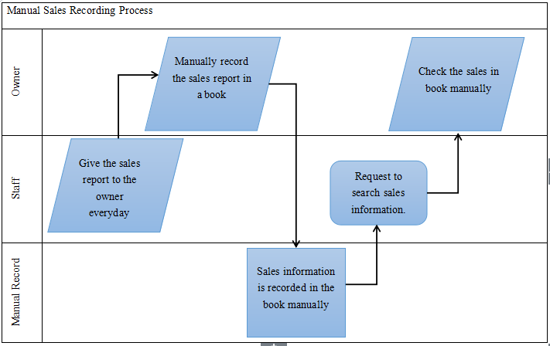

Figure 2.3.2 Desa Mart Sdn Bhd - As-Is Check Inventory Process

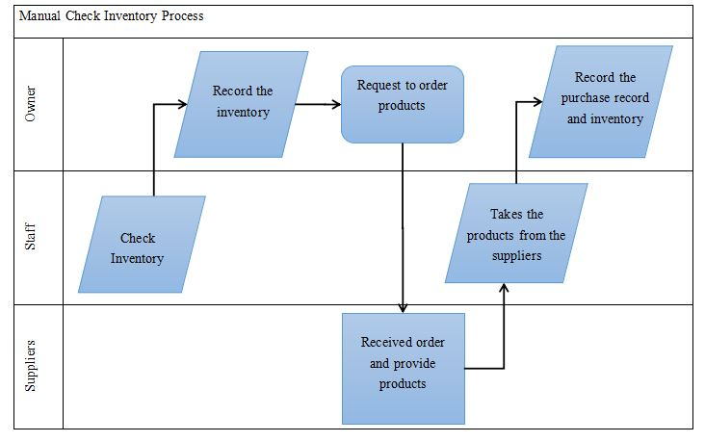

**3.0 DESIGN**

**3.1 Introduction**

Based on the initial research, Desa Mart currently does not use any digital platform as a means of recording their sales and inventory. So, it is believed that Desa Mart will have an increase in management effectiveness by using computer-based inventory management system. This system will mainly be used by the owner who needs to keep the sales records and search for a particular record. The system will also allow the owner to check for the available stock in the store. The main purpose of this system is to keep all the records in the store secure and obtain a particular record easily. This system cannot be accessed by anyone except the owner. The design of the system was created by keeping in mind the requirement and accessibility of user.

**3.2 System Flowchart (Proposed System)**

Figure 3.2.1 Flow chart of search engine

Figure 3.2.2 Flow chart of input inventory

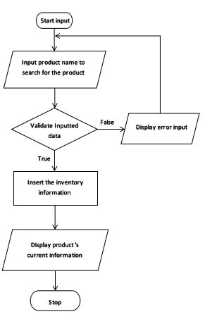

`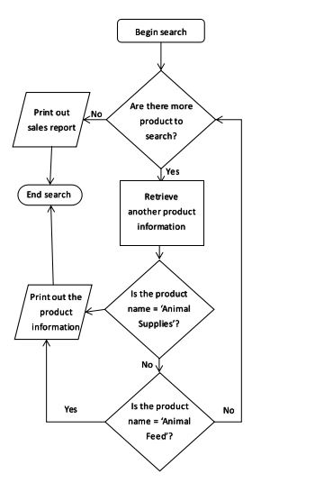

**3.3 Data Flow Diagram – Context Diagram & DFD**

Figure 3.3.1 Context Diagram

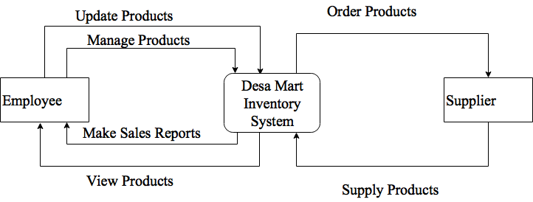

Figure 3.3.2 ERD Diagram

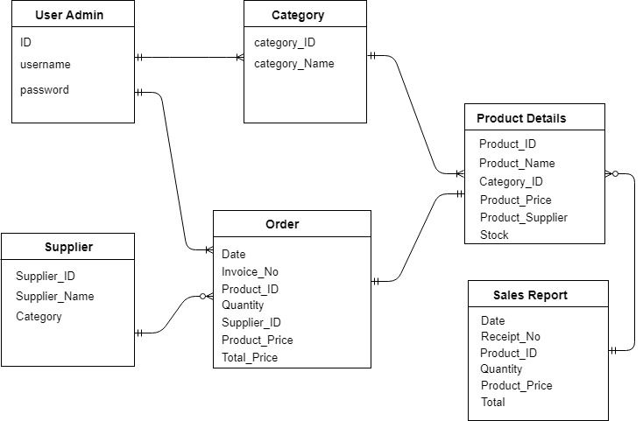

Figure 3.3.3 DFD Level 0 diagram

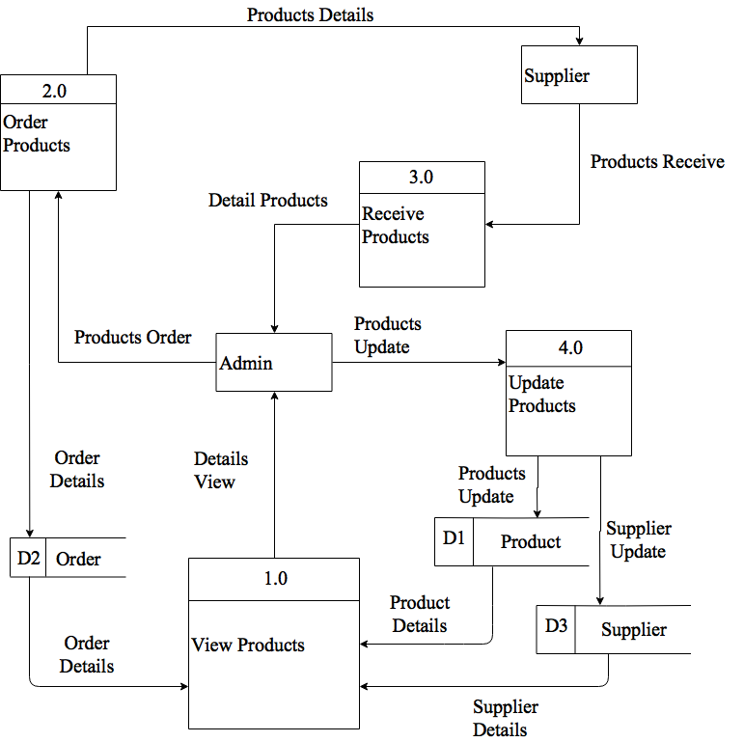

Figure 3.3.4 DFD Level 1 diagram

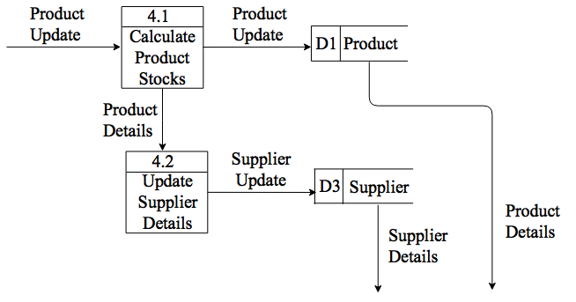

**3.4 Software and Hardware Requirements**

These are list of software and hardware that used in this project.

Table 3.4.1 Software Requirement

|  |  |
| --- | --- |
| Software | Usage |
| Operating System: Windows 10 | To control the all of the process and application software in computer |
| Xampp (PhpMyAdmin) | To create the database system |
| Dreamweaver | To create the user interface using php coding |
| Snipping Tools | To get certain part of figures |
| Windows Media Player | To hear the interview recorded |
| Windows Image Viewer | To see the picture taken in the company |
| Google Chrome | To search additional information from the internet |
| Acrobat Reader | To read PDF files |
| Microsoft Word 2016 | To write proposal and final report |
| Microsoft Project 2013 | To create Gantt Chart |

Table 3.4.2 Hardware Requirement

|  |  |
| --- | --- |
| Hardware | Usage |
| Desktop | To finish the project and store all of the data |
| Keyboard | To input the words to make proposal and final report |
| Printer | To print out the report and proposal |
| Speaker | To hear the recorded interview session |
| Mouse | To navigate the mouse pointer |

**Conclusion**

Basically, the introduction of our project consists of problem definition, objectives, scope and significance. These five criterias are important before we determine what database system should be created so that the student will stay in the right path and achieve the target set before they decide to develop the database system. Since the company we choose is using the traditional way to record the sales records by handwriting in a book. It seems like not secure and will had a hard time to search for a particular sales records. So we plan to create a computer-based inventory system which consists of database. The model used in this project is the Throwaway Prototyping model which is really suitable for project with unfamiliar technology and unclear user requirement as we can do the design multiple times to satisfy the users. The Gantt Chart is made according to the task we done. It is easy to view it as we can see the time length and the person in charge to do the task.

Before we start to develop our database system, we had analysis out the data collected by prepare an interview and observation between the owner and the company. We analysis out the actual as-is system and help them create a useful computer-based inventory system that bring benefit to the company.

Once the business needs are identified, a solution that meets the needs of the client was defined. To ensure it will support business requirements, we had created a system which will implement and accommodate every task correctly and achieve all general user requirements. The sequence, the hierarchy and the tasks are all analysed and recorded in a form of flowchart where it can be easily understood. So, a user interface with minimal and flexible interaction was created. ERD and DFD is created according the user requirement to create a effective to-be system. Lastly, the software and hardware used are also listed with the functions explained towards the project.

In conclusion, since database system in digitally is more effective in management, so the project is about to create a computer-based inventory system that contain database to let user create, read, update and delete data.

**Reference**

1. Special Topics in Computer Science: Basic Concepts, University College Cork, Ireland, October 15th 2009, <http://www.cs.ucc.ie/pipermail/cs2501/attachments/20091015/a1d4fcea/attachment-0004.pdf>
2. GCSE Bitesize, Database and Data Capture, BBC, 2014, http://www.bbc.co.uk/schools/gcsebitesize/ict/databases/2databasesrev4.shtml

1. Special Topics in Computer Science: Basic Concepts, University College Cork, Ireland, October 15th 2009, http://www.cs.ucc.ie/pipermail/cs2501/attachments/20091015/a1d4fcea/attachment-0004.pdf
2. GCSE Bitesize, Database and Data Capture, BBC, 2014, http://www.bbc.co.uk/schools/gcsebitesize/ict/databases/2databasesrev4.shtml